IYENGAR® YOGA AUDERGHEM, Rue E. Henrard 11, 1160, Bruxelles
Dorka Gero, +32 470 577 539, gdorka@yahoo.co.uk
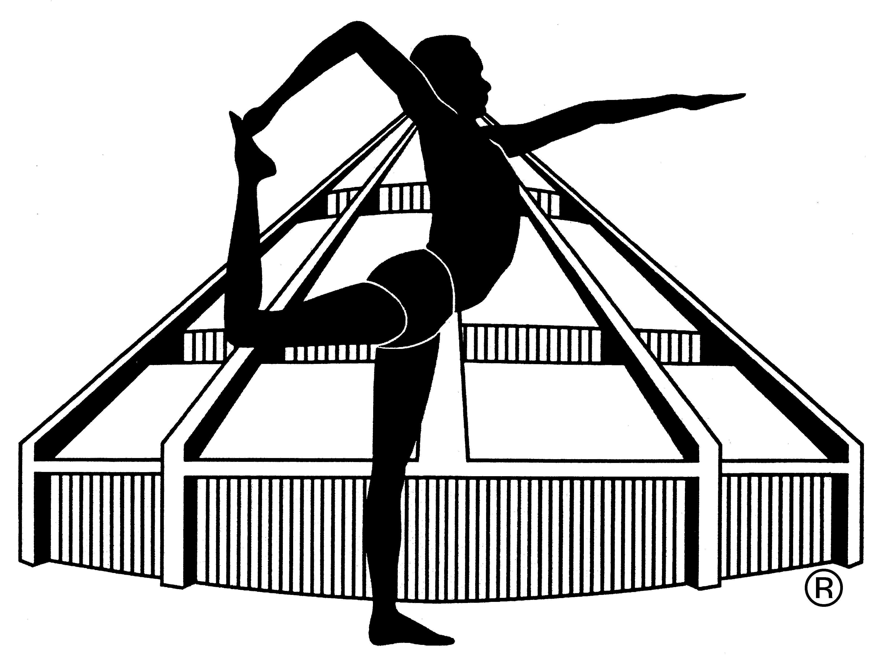

APPLICATION FORM FOR INTENSIVE SUNDAY MORNINGS 2023/2024

NAME: ……………………………………………………………………………………………
PHONE NUMBER: ……………………………………………………………………………
EMAIL ADDRESS: ……………………………………………………………………………
Previous Iyengar® yoga practice YES/NO, how many years ……………..
Previous practice of other yoga YES/NO, how many years ………………..
Experience of inverted postures (headstand, shoulder stand) YES/NO
Health condition (injuries, operations, blood pressure problem, hernia, other) ………………………………………………………………………………………………………
Other remark: …………………………………………………………………………………
………………………………………………………………………………………………………
I register for the following dates (please underline) and pay today the amount of …………euros to the account of Dorka Gero (ING bank account BE93 3770 8036 7567) or in cash.
1) 17 September, 2023, 2) 15 October, 2023 , 3) 19 November, 2023 4) 10 December, 2023, 5) 14 January,2024, 6) 11 February, 2024 7) 17 March, 2024, 8) 14 April, 2024, 9) 19 May, 2024, 10) 16 June, 2024

Date: ……………………………… Signature: ……………………………….

