IYENGAR® YOGA AUDERGHEM, Rue E. Henrard 11, 1160, Bruxelles
Dorka Gero, +32 470 577 539, gdorka@yahoo.co.uk
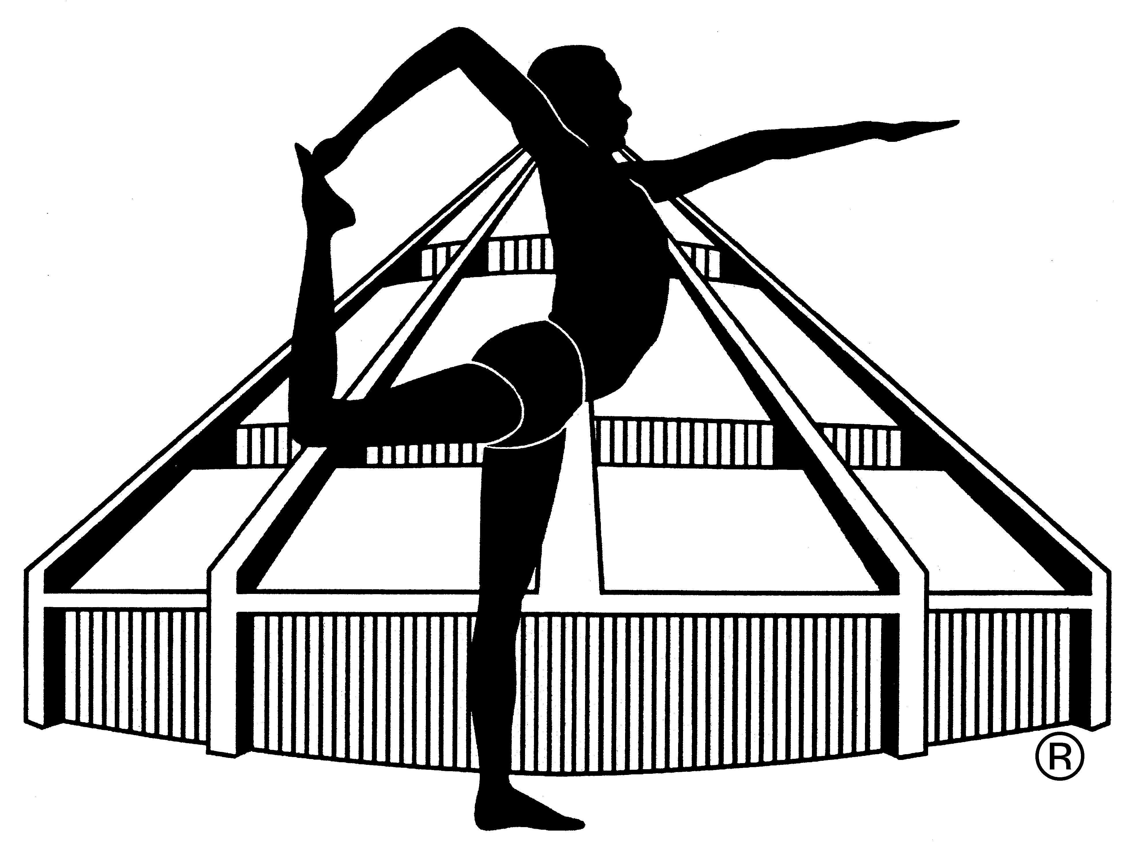

APPLICATION FORM FOR INTENSIVE SUNDAY MORNINGS 2022/2023

NAME: ……………………………………………………………………………………………
PHONE NUMBER: ……………………………………………………………………………
EMAIL ADDRESS: ……………………………………………………………………………
Previous Iyengar® yoga practice YES/NO, how many years ……………..
Previous practice of other yoga YES/NO, how many years ………………..
Experience of inverted postures (headstand, shoulder stand) YES/NO
Health condition (injuries, operations, blood pressure problem, hernia, other) ………………………………………………………………………………………………………
Other remark: …………………………………………………………………………………
………………………………………………………………………………………………………
I register for the following dates (please underline) and pay today the amount of …………euros to the account of Dorka Gero (ING bank account BE93 3770 8036 7567) or in cash.
- 18/09/2022, 2) 09/10/2022, 3) 13/11/2022, 4) 04/12/2022, 5) 15/01/2023, 6) 19/02/2023, 7) 26/03/2023,
8) 23/04/2023, 9) 28/05/2023, 10) 18/06/2023

Date: ……………………………… Signature: ……………………………….

