IYENGAR® YOGA AUDERGHEM, Rue E. Henrard 11, 1160, Bruxelles
Dorka Gero, +32 470 577 539, gdorka@yahoo.co.uk
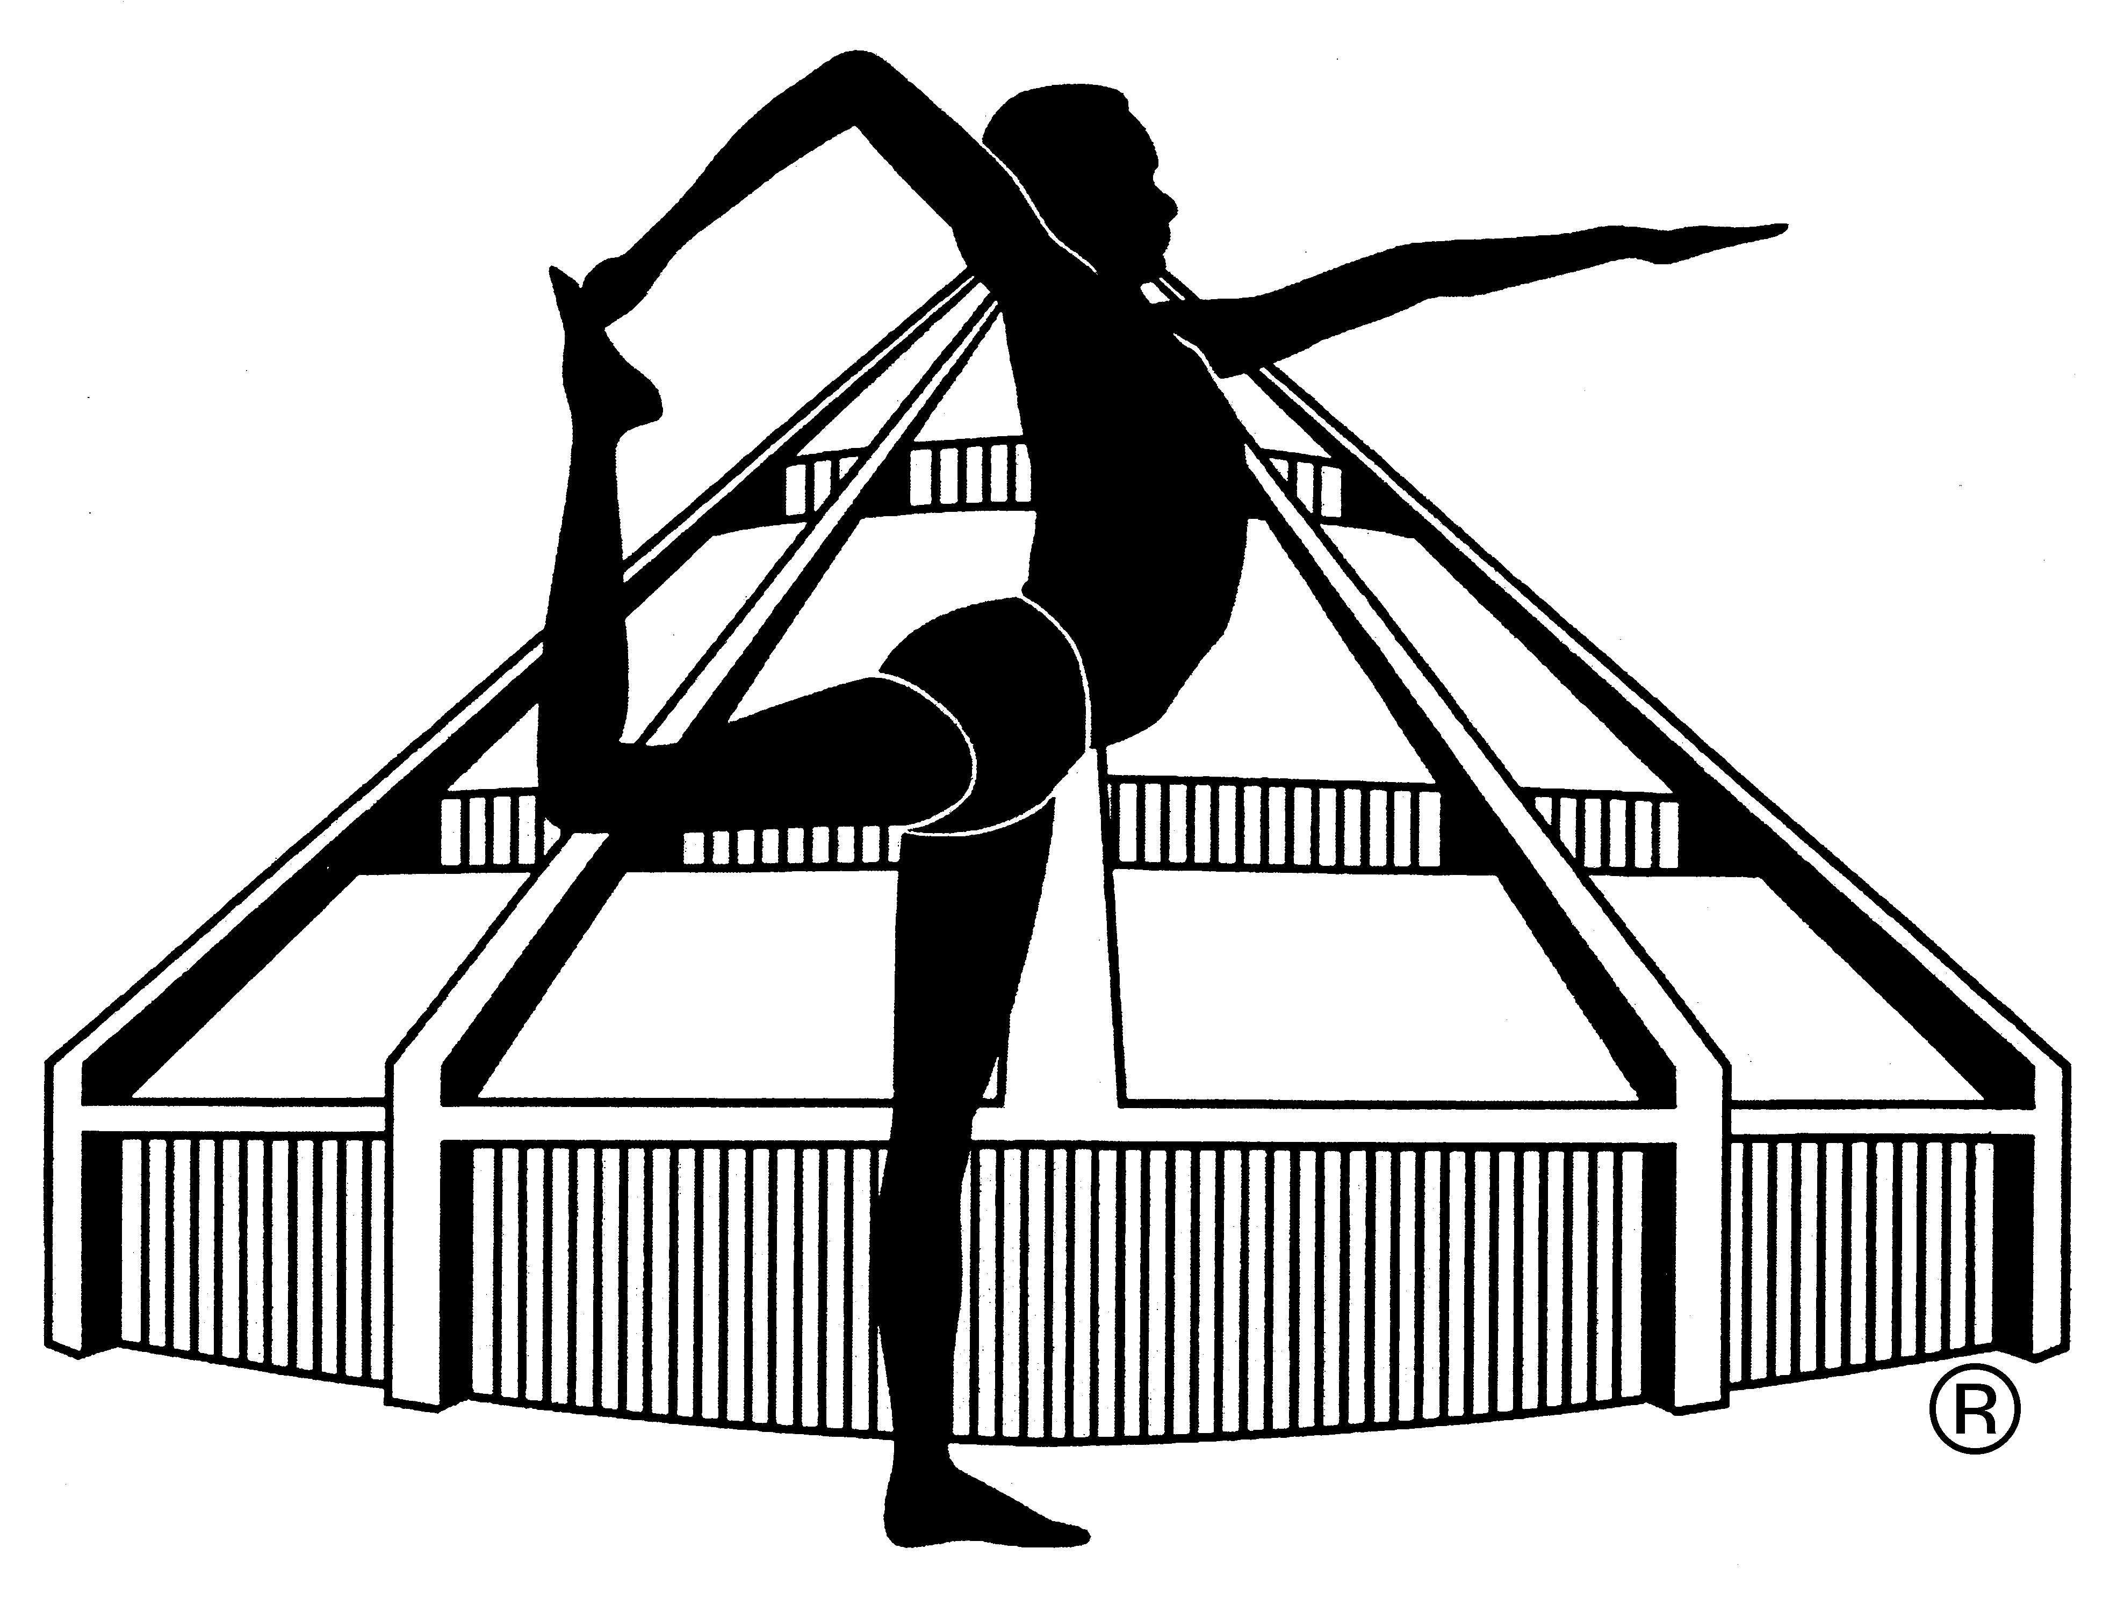

APPLICATION FORM FOR INTENSIVE SUNDAY MORNINGS 2021/2022

NAME: ……………………………………………………………………………………………
PHONE NUMBER: ……………………………………………………………………………
EMAIL ADDRESS: ……………………………………………………………………………
Previous Iyengar® yoga practice YES/NO, how many years ……………..
Previous practice of other yoga YES/NO, how many years ………………..
Experience of inverted postures (headstand, shoulder stand) YES/NO
Health condition (injuries, operations, blood pressure problem, hernia, other) ………………………………………………………………………………………………………
Other remark: …………………………………………………………………………………
………………………………………………………………………………………………………
I register for the following dates (please underline) and pay today the amount of …………euros to the account of Dorka Gero (ING bank account BE93 3770 8036 7567) or in cash.
- 26/09/2021, 2) 24/10/2020, 3) 14/11/2020, 4) 12/12/2020, 5) 23/01/2021, 6) 13/02/2021, 7) 20/03/2021,
8) 10/04/2021, 9) 08/05/2021, 10) 12/06/2021

Date: ……………………………… Signature: ……………………………….

